**Bardia Ardakanian**

**9831072**

**HW3**

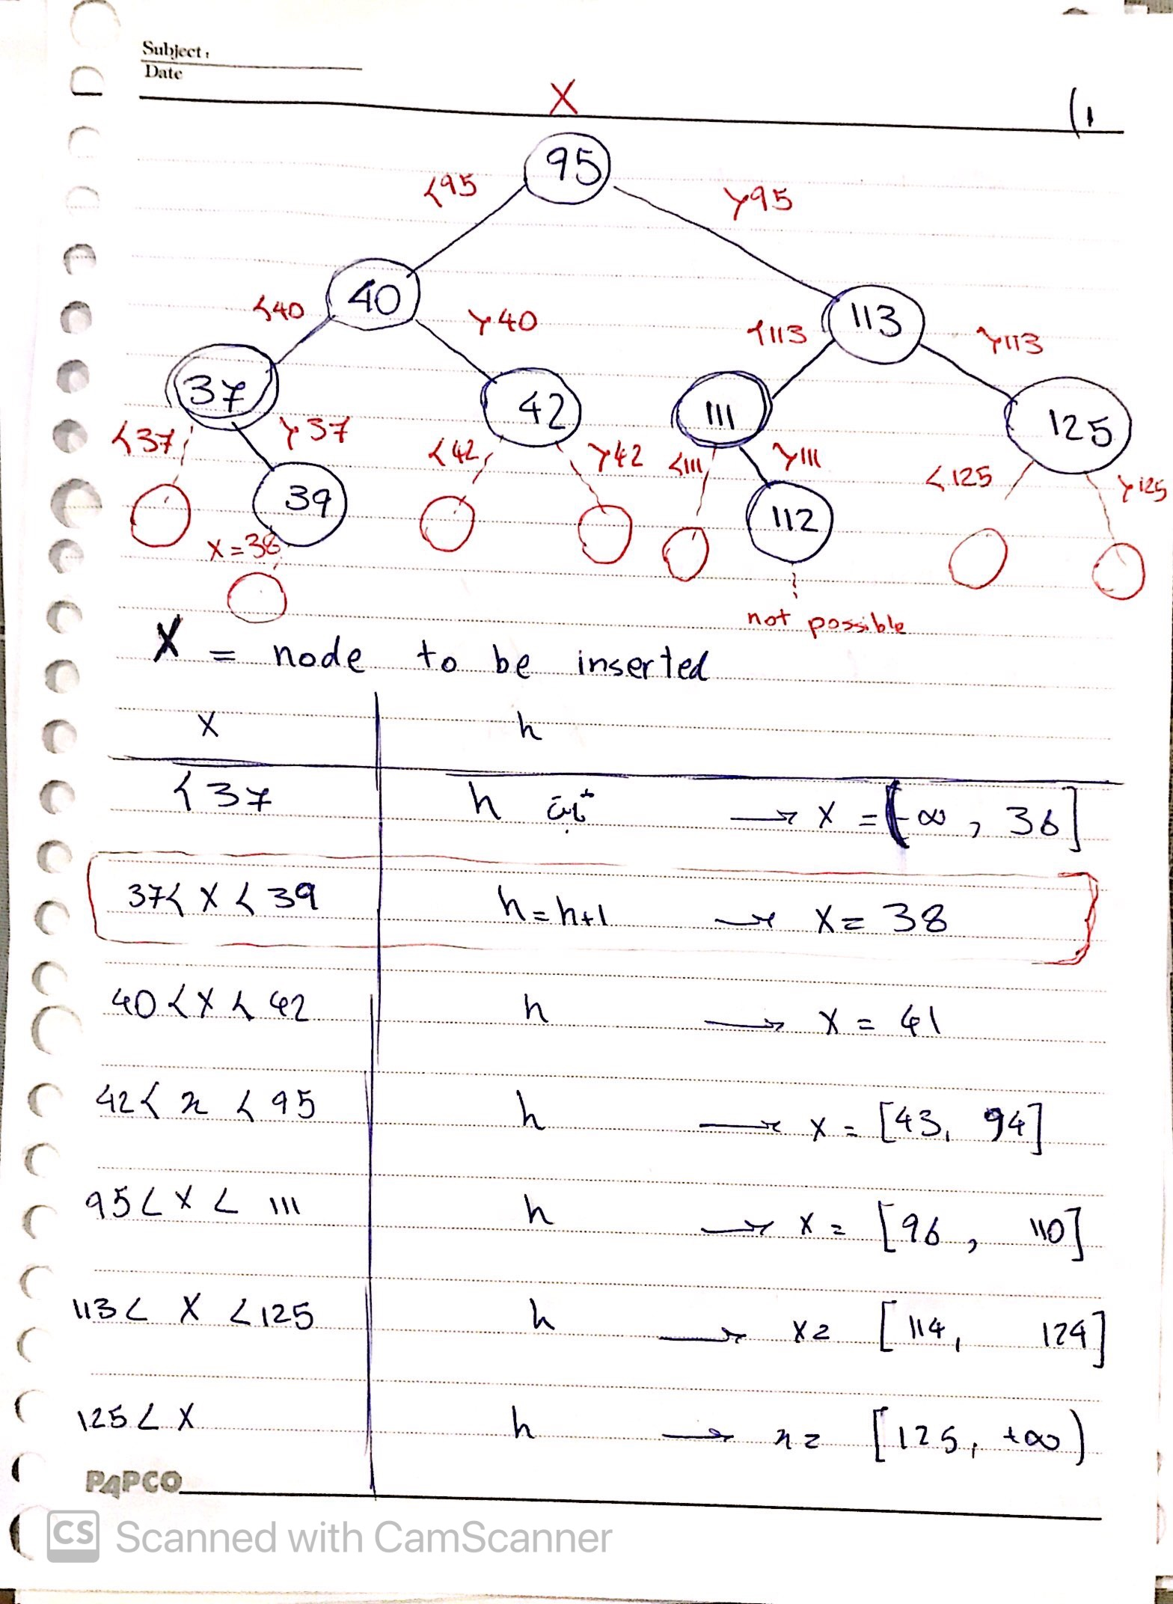Q2.

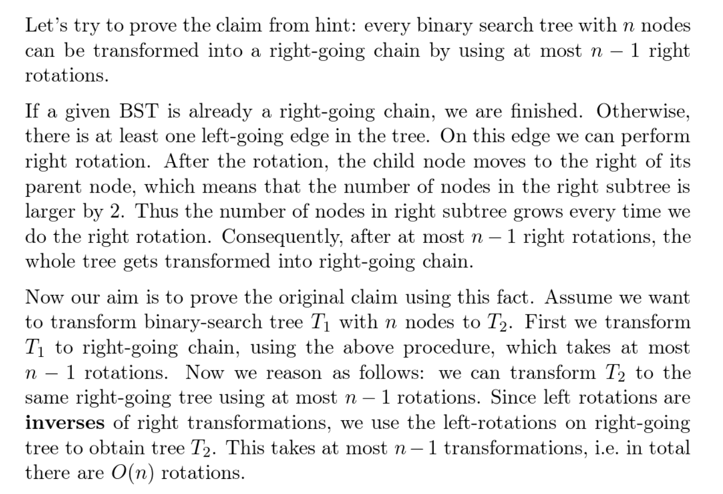

Let

LEFT = an entire left linked list binary tree

RIGHT = an entire right linked list binary tree.

You can easily rotate LEFT to RIGHT in (n-1) rotations.

e.g: n = 3

3 2 1

2 to 1 3 to 2

1 3

Proof: Since by definition, each right rotation will increase the length of the right most path by at least 1. Therefore, starting from right most path with length 1 (worst case), you need at most (n-1) rotations performed to make it into RIGHT.

Thus, you can easily conclude that any arbitrary shape of binary tree with n nodes can rotate into RIGHT within (n-1) rotations. Let T_1 be node you begin with Let T_2 be node you end with.

You can rotate T_1 to RIGHT within (n-1) rotations. Similarly, You can rotate T_2 to RIGHT within (n-1) rotations.

Therefore, To rotate T_1 into T_2, simply rotate T_1 into RIGHT , then do the inverse rotation to rotate from RIGHT into T_2.

Therefore, you can do this in (n-1)+(n-1) = 2n-2 rotations in upper bound.

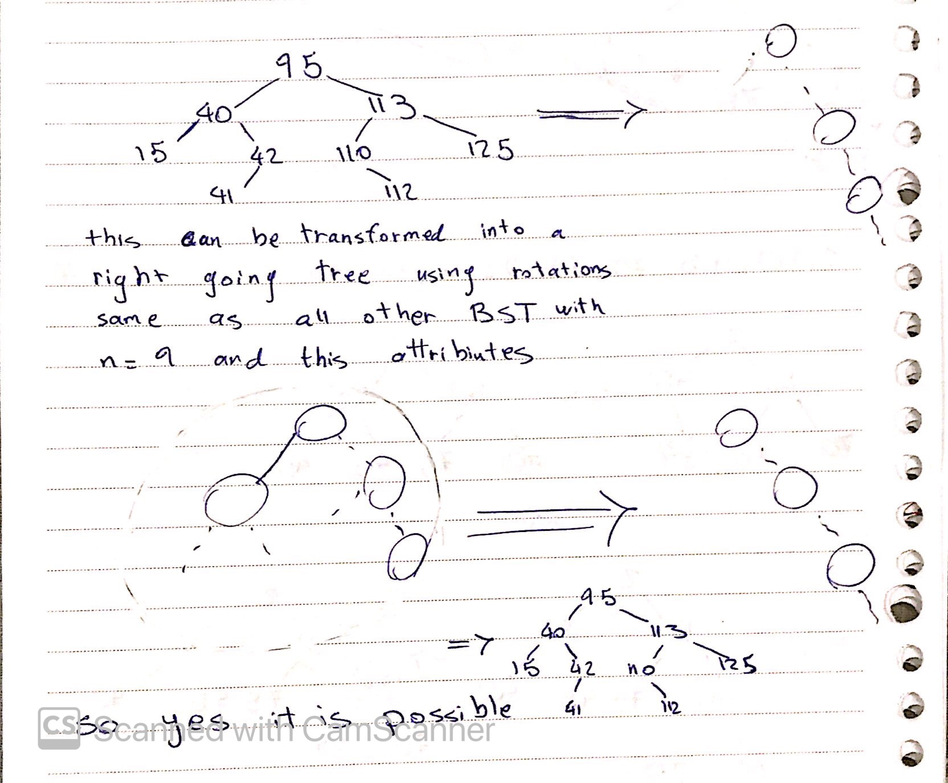Ps. The idea isn’t mine, its from stackoverflow, so yeah.

We assume this struct as node object for the following questions

node

{

    data

    Node left

    node right

}

node root

Q3.

Inorder:

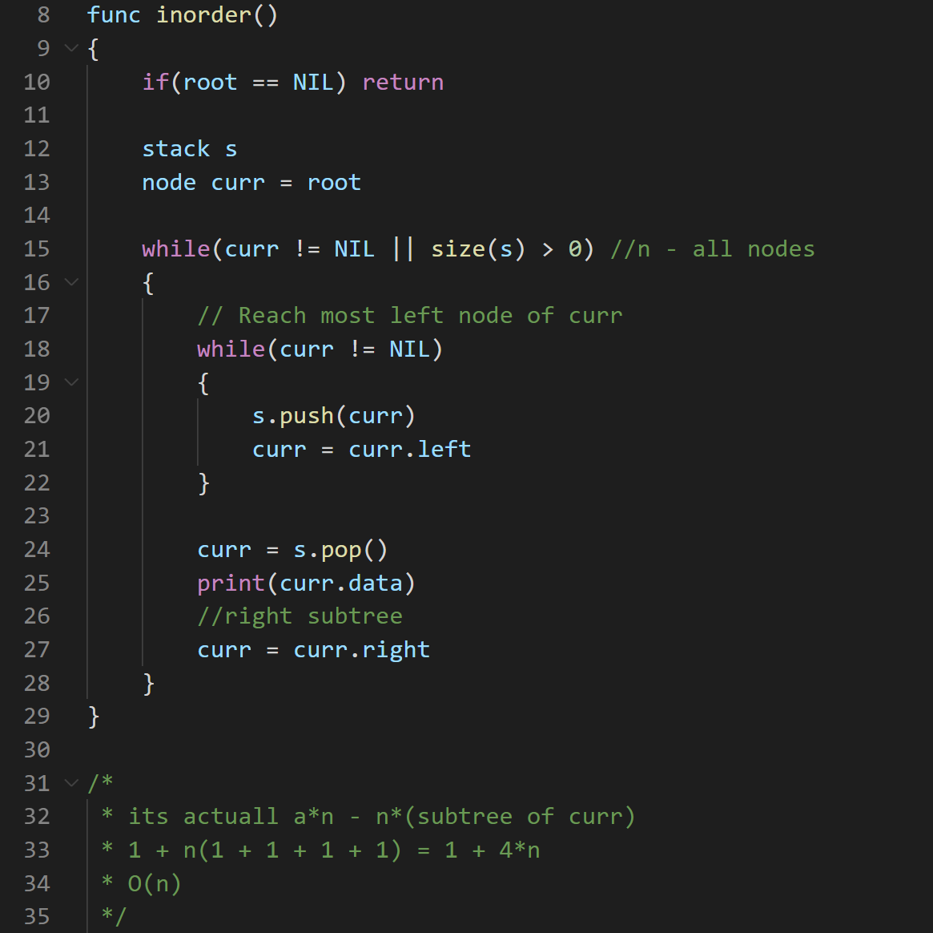

Postorder:

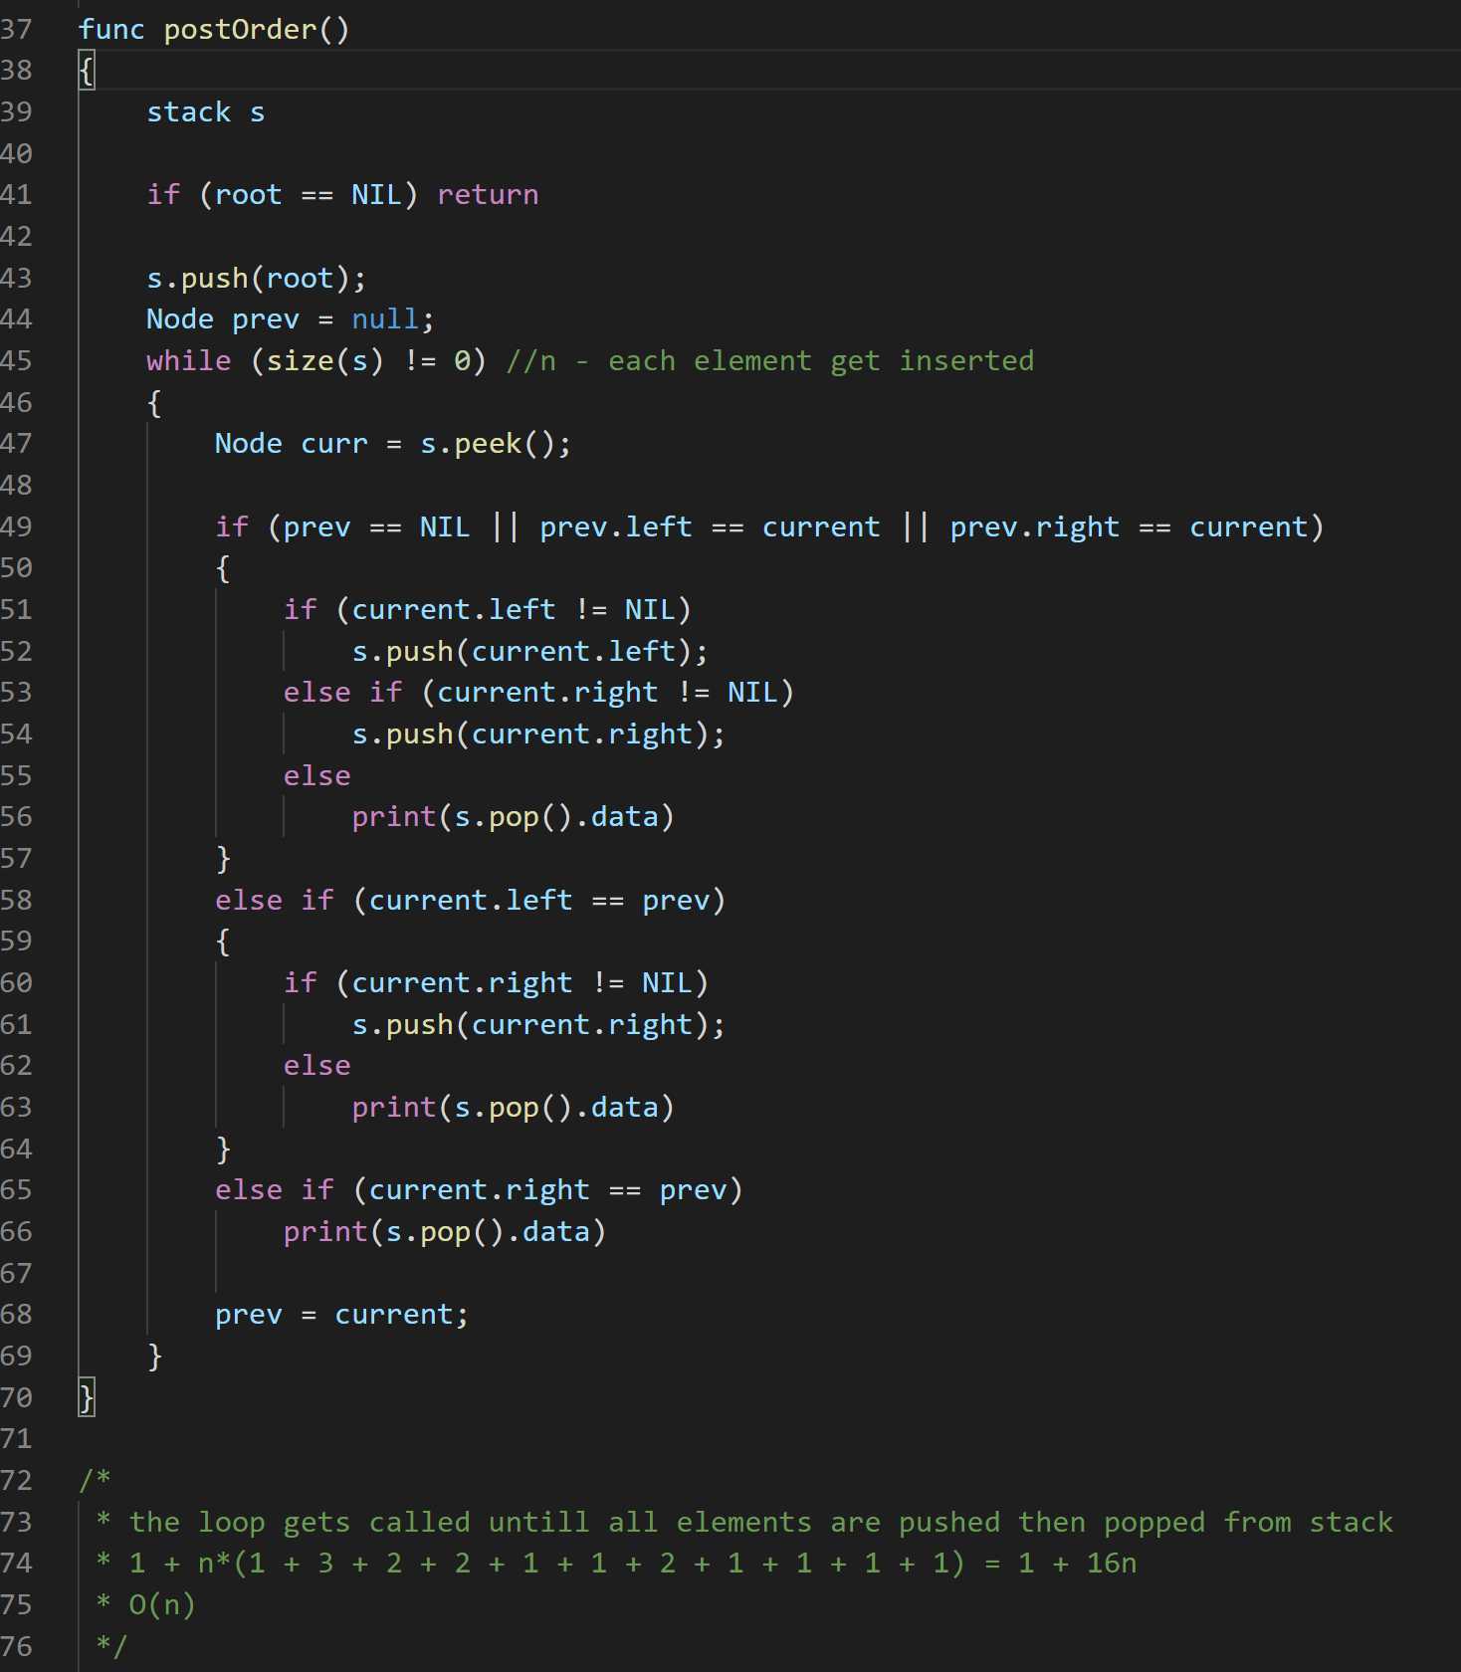

Prerder:

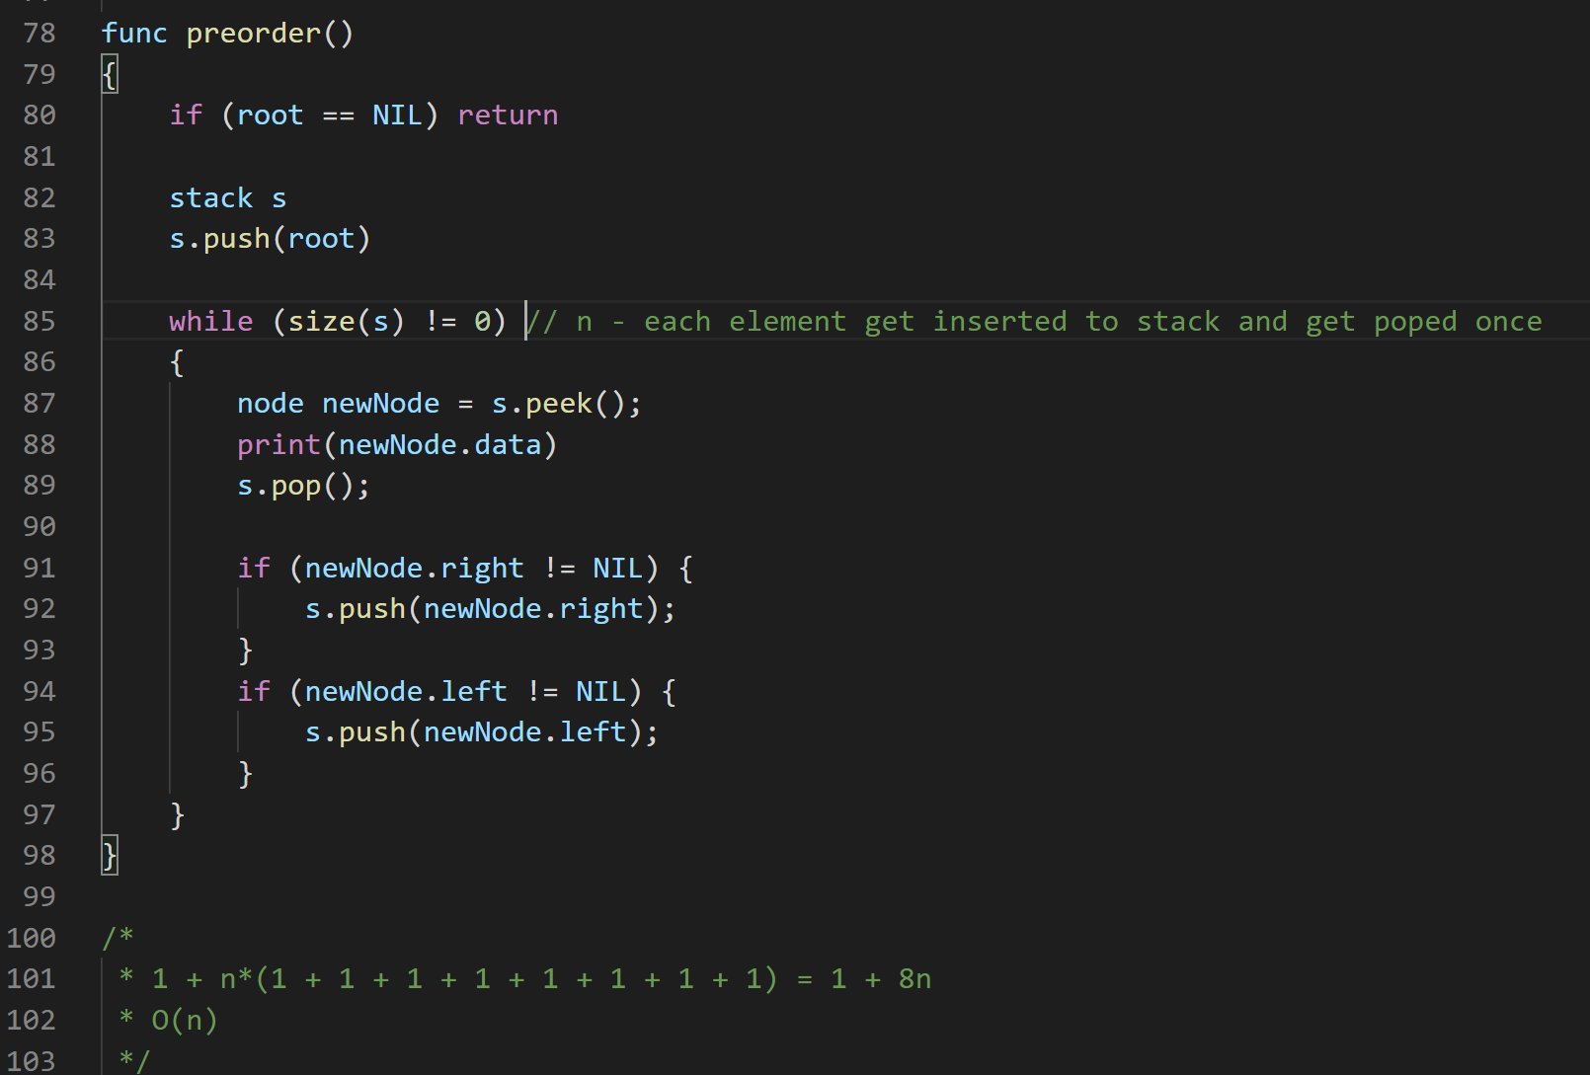

Q4.

a)

b)

//Find inorder and preorder traversals of tree, store them in

two auxiliary arrays inT[] and preT[].

//Find inorder and preorder traversals of subtree, store them

in two auxiliary arrays inS[] and preS[].

//If inS[] is a subarray of inT[] and preS[] is a subarray

preT[], then S is a subtree of T. Else not.

func is_subtree(node tree, node subtree)

{

    int inT[] = tree.inorder()

    int preT[] = tree.preOrder()

    int inS[] = subtree.inorder()

    int preS[] = subtree.preOrder()

    if (inS.subArray(inT) && preS.subArray(preS)) {

        return true

    }

    return false

}

//inorder and preOrder of a tree are O(n)

//is_subtree calls each function twice for two different trees

//we assume size of tree & subtree are n & m

//so we have order of growth n + n + m + m = 2(m + n)

//the function is from O(n+m) order of growth

Q5.

